November 9, 2019

Greetings!

On behalf of the City Council of the City of San Mateo, I am honored to express our support for 25th Anniversary Gala of the Council on America-Islamic Relations, San Francisco Bay Area (CAIR-SFBA).

We commend and applaud the work of CAIR-SFBA as they continue work to uphold the civil rights of American Muslims through civic engagement, legal services, media outreach & education, and youth empowerment. For twenty-five years, CAIR-SFBA has been successful in their mission to enhance the understanding of Islam, protect civil rights, promote justice, and empower American Muslims. Through the challenges and victories of the past twenty-five years, CAIR-SFBA continues to serve as a model for advocacy.

We would like to congratulate everyone committed to the fight for equality and understanding. We thank CAIR-SFBA and each of their community partners for their dedication to this issue as they work to foster a better understanding of the Islamic faith and its followers.

The success of our communities is dependent upon organizations such as CAIR-SFBA, who together with their supporters and staff, actively work to be a reliable resource and partner for media, public officials and policymakers, advocacy groups, and the interfaith and progressive communities. It is with great appreciation and respect for your cause that we extend our congratulations and sincerest commendations.

With Warm Regards,
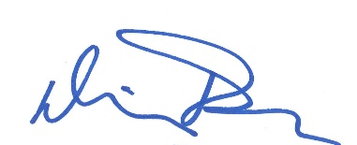

_____________________
Mayor Diane Papan

